Inquiry: Sumatran earthquakes with GPS
Earth Science Education
www.earthobservatory.sg
Teacher notes

Question 1) Describe the patterns that you can see in the data. What can we infer about the earthquake from this data?

Most clearly for the top 4 stations in North and East series:
- First, there is a permanent displacement
- Then, there are waveforms, similar to the trace of seismograph

As the distance to the epicenter increases, generally
- Displacement begins and ends later
- Waveforms arrive later
- Amount of displacement decreases
- Amplitude of waveforms decreases, though there are exceptions

Permanent vertical displacement not apparent

Interpretation: Earthquake source was closer to southern stations, as both displacement and waveforms occurred progressively later in northern stations, and amplitude of both is generally lesser in northern stations. The permanent displacement occurs before waveforms; propagation of displacement is faster than seismic waves.

Question 2) Plot vectors of the earthquake displacement for stations BSAT, SLBU, and PKRT on Figure 6, using the GPS data depicted on Figure 3. Use a scale of 0.1 m displacement = 2 cm on the page. It may help to sketch out north-south and east-west vectors separately and then use them to determine the overall horizontal motion graphically. Also mark your estimate of the earthquake epicenter on Figure 6.
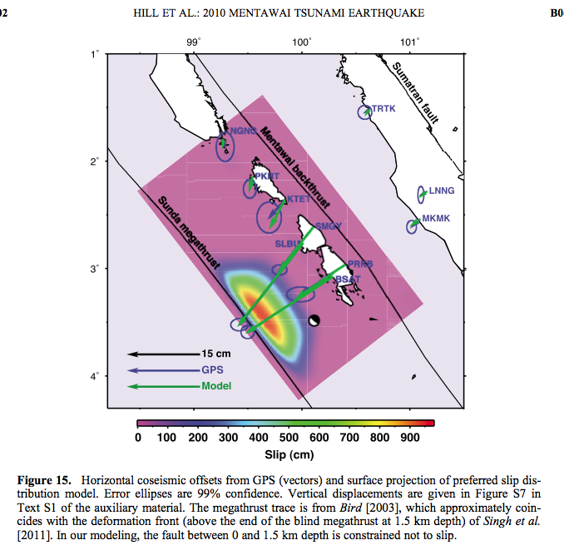

Question 3) What do the horizontal spaces represent (such as around the beginning of 2010)?

Data gaps. There is no internet at this station; field teams retrieve the data by difficult travel in small boats.

Question 4) How many major earthquakes can you identify in the time series? For each, estimate the date, horizontal displacement and direction, and vertical displacement and direction.

September 2007
Horizontal: 1200mm S, 1000mm W = 15600 mm SW
Vertical: 750 mm upward

October 2010
Horizontal: 300mm S, 400mm W = 500 mm SW
Vertical: 100mm downward

Question 5) The sources of both of these earthquakes were close to this station. One earthquake was M (magnitude) 7.8, while the other was M 8.4. One earthquake caused a 4m tsunami, while the other caused a 17m tsunami. Which do you think is which? Refer also to Figure 8.

September 2007, M 8.4, tsunami up to 4 m height, fewer than 80 casualties

October 2010, M 7.8, tsunami up to 17 m height, more than 500 casualties

The 2010 earthquake ruptured the shallow portion of the megathrust, updip of the 2007 rupture patch. This shallow rupture caused more seafloor deformation (thus larger tsunami) both because the rupture is closer to the seafloor and because the softer materials of the accretionary wedge deform more easily.

Question 8) Describe the pattern you see in the horizontal rates (Figure 9). Make a hypothesis that may explain this pattern.

The four island stations are moving ~20mm/yr faster to the northeast than is the mainland station (ABGS). Therefore, the islands are getting 20mm closer to the mainland every year. The crust in this area is being compressed in a NE/SW direction because of the subduction of the Indo-Australian plate beneath the Eurasian plate. This accumulating strain in the crust will eventually be released in an earthquake.

Question 9) Describe the pattern that you see in the vertical rates (Figure 10). Make a hypothesis that may explain this pattern.

Stations closer to the trench (PSMK, PBJO) are moving relatively downward, whereas stations farther from the trench (PBAI, ABGS) are moving relatively upward. Subduction of the Indo-Australian plate is dragging the leading (SW) edge of the Eurasian plate downward. Farther from the trench (PBAI, ABGS), compression is causing the overriding plate to flex upward. When a major earthquake occurs on the subduction zone, the vertical direction will reverse: areas close to the trench will move suddenly upward, whereas areas farther from the trench will move suddenly downward.

Question 10) Watch this cartoon animation of plate motion in Sumatra. Does the data above provide evidence for the kind of motion shown in the animation, or does it contradict it? Explain.

Earthquakes and tsunami in Sumatra (from Caltech)
http://www.youtube.com/watch?v=Hs5plIrCmWM

The evidence is consistent:
Horizontal: The leading edge of the overriding plate is pushed backward in the animation (equivalent to NE on the map) in the time between earthquakes.
Vertical: The island is moving downward in the time in between earthquakes.
Both motions reverse at the moment of the earthquake.

